**Preliminary Exploration: The Highest Ratings, Most Reviews, and Largest Size**

**Challenge**: Identify which apps are the highest rated. What problem might you encounter if you rely exclusively on ratings alone to determine the quality of an app?

**Challenge**: What's the size in megabytes (MB) of the largest Android apps in the Google Play Store. Based on the data, do you think there could be a limit in place or can developers make apps as large as they please?

**Challenge**: Which apps have the highest number of reviews? Are there any paid apps among the top 50?

.

.

..

…

..

.

.

**Solution: Preliminary Data Exploration**

This challenge should have been fairly straightforward if you remembered to use the .sort_values() function.

1. df_apps_clean.sort_values('Rating', ascending=False).head()

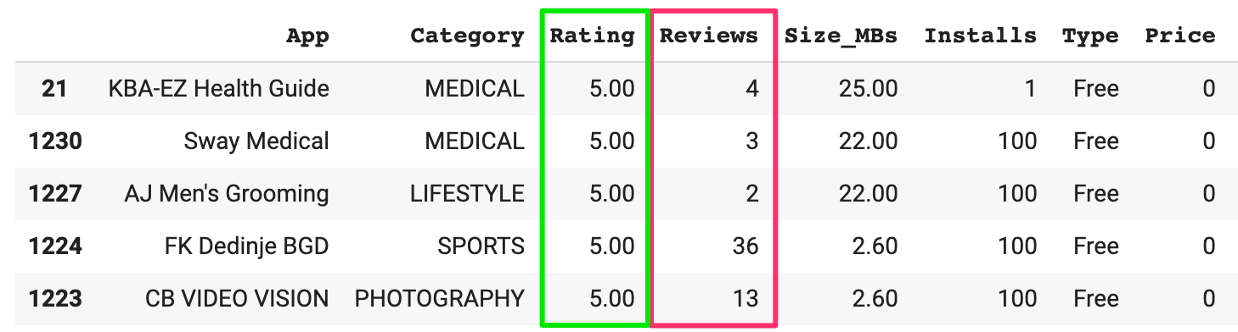

Only apps with very few reviews (and a low number on installs) have perfect 5 star ratings (most likely by friends and family).

1. df_apps_clean.sort_values('Size_MBs', ascending=False).head()

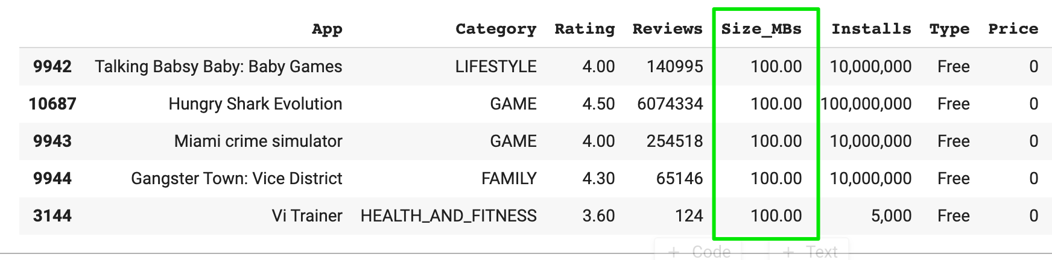

Here we can clearly see that there seems to be an upper bound of 100 MB for the size of an app. A quick google search would also have revealed that this limit is imposed by the Google Play Store itself. It’s interesting to see that a number of apps actually hit that limit exactly.

1. df_apps_clean.sort_values('Reviews', ascending=False).head(50)

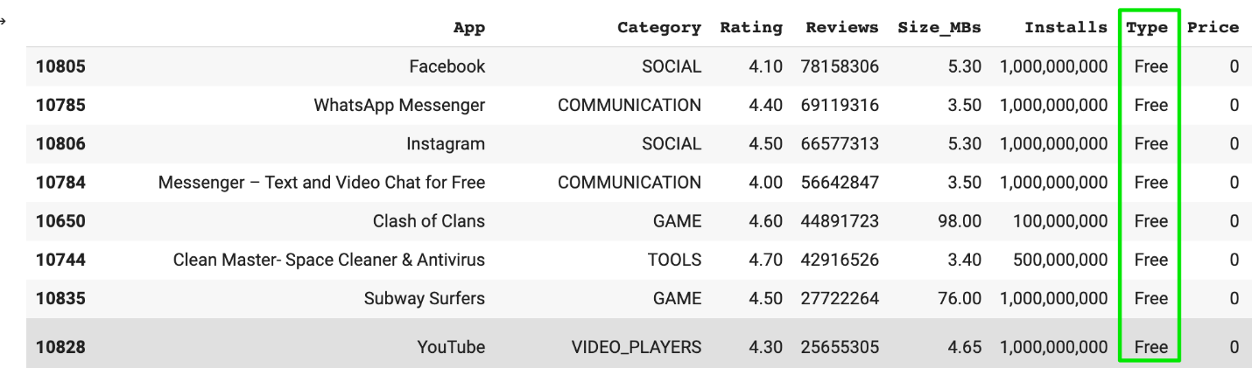

If you look at the number of reviews, you can find the most popular apps on the Android App Store. These include the usual suspects: Facebook, WhatsApp, Instagram etc. What’s also notable is that the list of the top 50 most reviewed apps does not include a single paid app! 🤔